Dear Parents:
We sincerely appreciate and are deeply grateful for your involvement. We couldn’t have done it without your support. We are also thankful that we are on-site at PS 110, PS 19, and Children’s Workshop School, and can pick-up students from nearby schools. We are the only after school program to accept Pre-K. We accept students from Pre-K to 5th Grade. We are a “No Added Sugar After-School”. We do not offer packaged or processed foods. We offer certified-organic fresh fruits as snacks, and spring water. We believe we are what we eat, and that unhealthy food negatively affects our behavior, attitude, and focus. You can choose us for anywhere between 1 and 5 days per week.
For more information about our summer camp program, please go to. http://www.superhappyhealthykids.com/summer-camp.html.
To learn more about our Holiday Camp, please go to
http://www.superhappyhealthykids.com/holiday-camp.html

If you are not familiar with our program, Super Happy Healthy Kids is a non-profit, Department of Education approved after school program vendor, and fully insured. Our mission is to engage kids and pass on core values of kindness, leadership and motivation. We are not a tutoring service, but we do
assist your children with homework. We believe getting good grades and excelling at school can be fun.
We promote kind words and kind acts in everything that we do. We teach our kids to value mindfulness and winning together. The kids meditate for a few minutes every day. Doing so helps them to be more focused, kind, and do better in school. We encourage our kids and their families to say kind words and do kind acts through our activities. Your children will learn to improve their social skills, hone their senses and control their minds and bodies. We have an incredibly fun and professional team dedicated to building up our children to be amazing leaders with strength and compassion.
We will be offering homework assistance and mindful meditation every day, along with 10 different activities each week. – Outdoor/Indoor Sports, Chinese Calligraphy, Martial Arts (Japanese Karate), Spanish Language, Chinese (Mandarin) Language, Yoga, Healthy Cooking/Edible Art, Music, Art and Lego-Mania.
For the next school year, our after school program will begin on Monday, September 10th, 2018 and end on the last Friday before school ends, in June of 2019.
Thank you to everyone who has helped us spread our message positivity and kindness. We have started a referral program: For every successful referral, you will receive a $200 credit toward your child’s enrollment in our program. Our application can be found on our website at www.superhappyhealthykids.com. Click Register!, click After School Applications, and download your chosen school’s registration form. You can email us at superhappyhealthykids@gmail.com or text us at (917) 369-0032.
Wishing you and your family Good Health and Success,
Super Happy Healthy Kids Team

Why We Are Different:
We have discovered that other after school programs and Summer camps have been copying our program, which is a testament to just how good we are. However, their kids won’t receive the same heart and spirit that we provide:
- We invest in building character, integrity and responsibility in each child. Priceless lifetime Skills. Each child speaks only kind words and does kind acts.
- We are a “NO” added sugar after-school program. We do not offer packaged or processed snacks. Our program provides certified organic fresh fruits as snacks. We offer Spring Water for our kids. We educate our kids to make good choices. We do NOT offer cakes, cookies or candies. We believe we are what we eat, and that unhealthy food negatively affects our behavior, attitude, and focus.
- We instill our kids with the importance of sincerity and manners.
- We give homework assistance and make it fun.
- We teach our kids how to deal with bullies and how to NOT be a bully.
- We inspire our kids to follow their hearts, be good friends and great listeners while deeply appreciating their parents, siblings and teachers.
- We believe in raising smart, kinder and gentler kids to have the moral compass to make this world even better.
- We are an old-school, traditional after school program. We nurture each child’s unique gifted talent. We encourage our kids to “Win together.”
- We send you photos so you know what your child is up to each semester.
- We accept Pre-K.
- Unlike other programs, we provide fun and enriching activities every day. Your child will receive 12 activities every week. Our program includes material fees.
- We love what we do and our kids know it. We teach them to have FUN and to LOVE school and their families.

Join our movement to stamp out meanness and bullying™
Our usual schedule – drop off from teachers at dismissal, indoor or outdoor activities to get their bodies moving, fresh fruits as snacks, mindfulness meditation to learn how to be centered and grounded, homework, and 2 activities per day. Your child will have 15 different activities and learn three different languages, plus meditation every day. Our activities are: Karate, Lego-Mania, Art, Yoga, Outdoor/Indoor Sports, Healthy Cooking/Edible Art, Music, Chinese Calligraphy, Math, Little Shakespeare, and language lessons (Mandarin Chinese, Spanish, and Japanese (for Karate).

Join our movement to stamp out meanness and bullying™
Our mission is changing lives with kind words and kind acts™
Our after-school ends at 5:00 PM. Extended day till 5:45 PM is available for a nominal fee.
Our application can be found on our website at www.superhappyhealthykids.com. For any questions, email us at superhappyhealthykids@gmail.com, or text us at 917-369-0032.
Wishing you and your family Good Health and Success,
Super Happy Healthy Kids Team
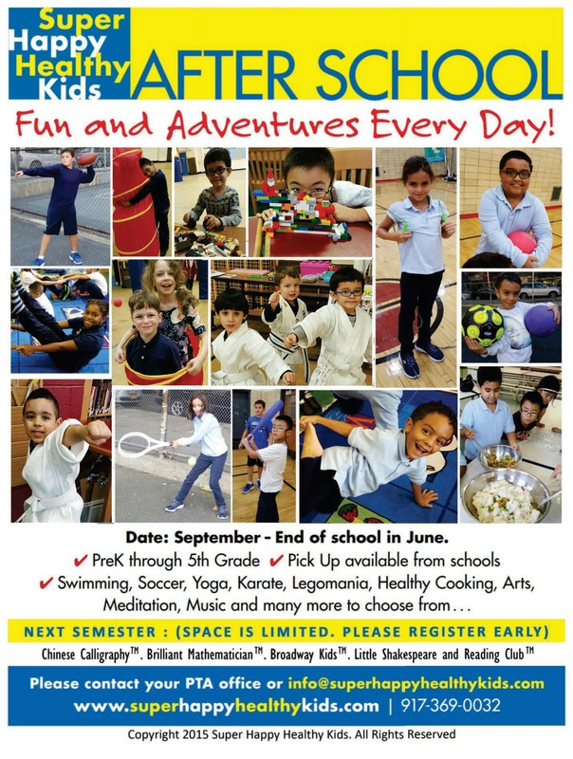

Programs
- Monday: Outdoor/Indoor Sports and Chinese Calligraphy
- Tuesday: Mandarin Chinese and Karate
- Wednesday: Spanish and Yoga
- Thursday: Cooking/Edible Art and Music
- Friday: Art and Lego-Mania

Normally scheduled pick-up is by 5:00pm.
Extended pick-up until 5:45 is available for a nominal fee.

Program Options | Normal Pickup (5:00 PM)
5 Days per Week | $430 Paid Monthly  ($100 Paid Weekly)  •Pickup is at 5:00pm. late pickup is available till 5:45pm for an extra $12/day, with an additional $2 for each minute past 5:45.
4 Days per Week | $387 Paid Monthly  ($90 Paid Weekly)
3 Days per Week | $344 Paid Monthly  ($80 Paid Weekly)
2 Days per Week | $301 Paid Monthly  ($70 Paid Weekly
1 Day per Week | $258 Paid Monthly  ($60 Paid Weekly)
Administration and Equipment Fees | $175 Registration  $75 Karate Uniform (where applicable)  $120 Administrative Fee  $150 2 Parent/Teacher Conference Care days  $20 T-shirt (1 per child)  (Total=$540)  $15 Service fee for declined credit card transactions per incident,  $40 fee for returned checks.  Returning Students: $250 discount for 5 days/week, $200 for 4 days/week, $150 for 3 days/week, $100 for 2 days/week, $50 for 1 day/week.
* For weekly/monthly payment students, an automatic deduction per week or month will be charged to your credit card until the end of the school year including school holidays. Weekly, monthly, or other payment plans are responsible for payment for the full school year, from September through June, regardless of whether you choose to drop out before the end of the school year.

2019 AFTER-SCHOOL APPLICATION FORM

Name of School:_______________ Please Circle Which Day(s) Your Child Will Attend: M T W T F

Grade: _____________ Age: _____ Date of Birth: ___________
Teacher’s name: ___________________________________________ Class Rm #:_____________________

Student’s Last Name: __________________ Student’s First Name: __________________ Sex: M / F
Address: ____________________________ Apt: _______ City:_____________ State:____ Zip Code: _______
Phone (H): _______________ (M): _____________________Email Address: ___________________________

Parents or Guardian’s Name/s: ______________Dad: _________________ Phone: ______________________

Mom: ___________________ Phone: _________________________________ Who else will be picking up your child?: ____________________________ Emergency Contact #1: _______________________________ Phone: ______________________ Doctor’s Name: _______________________ Doctor’s Phone: _____________________ Doctor’s Address: ______________________________________________________ Allergies?:__________________________________________________________________________________
Anything we need to know about your child(ren)?________________________________________________ ___________________________________________________________________________________________

Student/parent/guardian hereby releases, discharge and absolves NYC DOE, P.S. 19, P.S. 110, Children’s Workshop School, Esther Yang, Super Happy Healthy Kids, Simple Healthy Living and its agents and employees of and from any and all liabilities and responsibility for any and all accidents and/or injuries students may sustain during promotion and/or class whether the same are caused by or attributed to the negligence, NYC DOE, P.S. 19, P.S. 110, Children’s Workshop School, Esther Yang, Super Happy Healthy Kids, Simple Healthy Living, or the negligence of its agents and/or employees. The applicant/parent/guardian consents to the use of, and waives any compensation for all picture, media coverage, etc. by Esther Yang, Super Happy Healthy Kids, Simple Healthy Living or those designated by them. All fees are non-refundable and non-transferable. As a safety issue, we have the right to expel any child/family that is abusive to our participating kids and team members. * For weekly/monthly payment students, an automatic deduction per week or month will be charged to your credit card until the end of the school year including school holidays. Weekly, monthly, or other payment plans are responsible for payment for the full school year, from September through June, regardless of whether you choose to drop out before the end of the school year.
Parent or Guardian: _______________________________________Date: ______________________

Credit Card Information:
Name on the Card:____________________________________________________________________________________
Card Number: _______________________________________________________________________________________

Address: ____________________________________________________________________________________________

Zip Code: ____________ Phone: ____________________ Email: ______________________________________________
Type of Card: ____________ Exp:____________ Security Code:___________ Amount Total $___________
* For monthly payment students, an automatic deduction per week or month will be charged to your credit card until the end of the school year including school holidays.
`•Pickup is at 5:00pm. late pickup is available till 5:45pm for an extra $12/day, with an additional $2 for each minute past 5:45.
Authorization Signature:
______________________________________________________________________________
Thank you! Wishing you and your family Good Health and Success.

